**Convert emoji into text in python**

**AIM :**

To write a program to convert emoji into text in python

**OBJECTIVES :**

Understanding how to handle and process emoji characters within a text-based application or system. Converting emoji characters to their textual representation for compatibility with systems that do not support emoji. Enabling the analysis and manipulation of text data containing emoji, such as sentiment analysis, natural language processing, and data mining. Enhancing user experience by providing support for emoji in applications that require text input and output. Ensuring consistent display and interpretation of emoji across different platforms and systems.

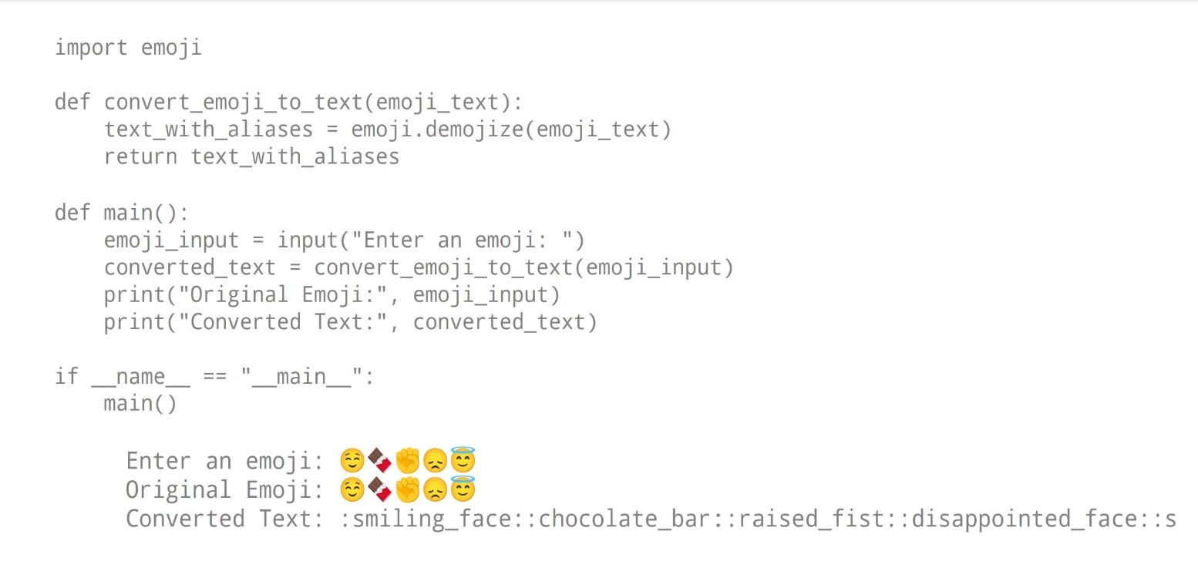**PROGRAM :**

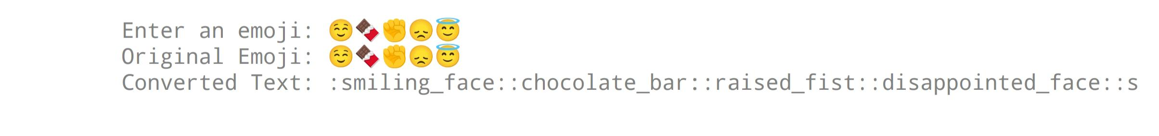**OUTPUT :**

**CONCLUSION :**

In conclusion, converting emoji into text in Python is an essential capability for handling and processing textual data that contains emoji characters. By achieving this conversion, applications and systems can ensure compatibility, facilitate analysis, and enhance user experience. Leveraging Python libraries such as emoji enables developers to seamlessly address the challenges associated with emoji handling